EXPERIMENT 4
Create Web page for Hotel room booking form: Use of input fields, labels, select, textarea, and buttons.

Objectives
- To design a hotel room booking form using HTML.
- To understand the use of input fields for collecting user details.
- To apply labels for form accessibility.
- To implement dropdown menus (select) and text areas.
- To create functional buttons for form submission and reset.
Tools Required
- Computer / Laptop with any OS
- Text Editor (VS Code, Sublime Text, Notepad++)
- Web Browser (Chrome, Edge, Firefox)

Theory
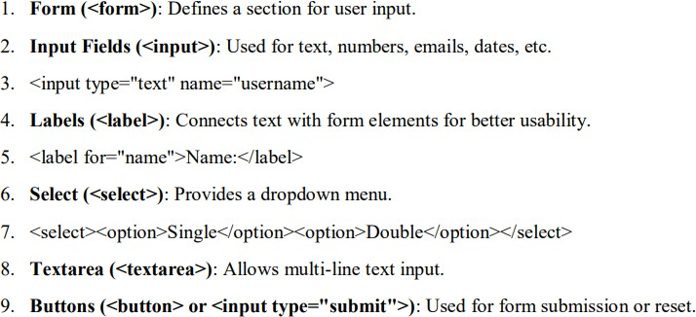

CODE IMPLEMENTATION

<!DOCTYPE html>
<html lang="en">
<head>
<meta charset="UTF-8">
<meta name="viewport" content="width=device-width, initial-scale=1.0">
<title>Hotel Room Booking Form</title>
<style>
body {
font-family: Arial, sans-serif;
background-color: #f2f3f5;
margin: 0;
padding: 0;
}
.container {
width: 500px;
background-color: #fff;
padding: 25px;
margin: 50px auto;
border-radius: 10px;
box-shadow: 0 0 10px #aaa;
}
h2 {
text-align: center;
color: #333;
}
label {
display: block;
margin-top: 10px;
font-weight: bold;
}
input, select, textarea {
width: 100%;
padding: 8px;
margin-top: 5px;
border: 1px solid #ccc;
border-radius: 5px;
box-sizing: border-box;
}
textarea {
resize: vertical;
}
.buttons {
text-align: center;
margin-top: 15px;
}
input[type="submit"], input[type="reset"] {
width: 45%;
padding: 10px;
margin: 5px;
background-color: #0078D7;
color: white;
border: none;
border-radius: 5px;
font-size: 16px;
cursor: pointer;
}
input[type="reset"] {
background-color: #f44336;
}
input[type="submit"]:hover, input[type="reset"]:hover {
opacity: 0.9;
}
</style>
</head>
<body>
<div class="container">
<h2>Hotel Room Booking Form</h2>
<form>
<label for="fullname">Full Name:</label>
<input type="text" id="fullname" name="fullname" placeholder="Enter your full name" required>

<label for="email">Email Address:</label>
<input type="email" id="email" name="email" placeholder="Enter your email" required>

<label for="phone">Phone Number:</label>
<input type="tel" id="phone" name="phone" placeholder="Enter your phone number" required>

<label for="checkin">Check-In Date:</label>
<input type="date" id="checkin" name="checkin" required>

<label for="checkout">Check-Out Date:</label>
<input type="date" id="checkout" name="checkout" required>

<label for="room-type">Room Type:</label>
<select id="room-type" name="room-type" required>
<option value="">--Select Room Type--</option>
<option value="single">Single Room</option>
<option value="double">Double Room</option>
<option value="deluxe">Deluxe Room</option>
<option value="suite">Suite</option>
</select>

<label for="guests">Number of Guests:</label>
<input type="number" id="guests" name="guests" min="1" max="10" required>

<label for="requests">Special Requests:</label>
<textarea id="requests" name="requests" rows="4" placeholder="Enter any special requests..."></textarea>

<div class="buttons">
<input type="submit" value="Book Now">
<input type="reset" value="Reset">
</div>
</form>
</div>
</body>
</html>

OUTPUT

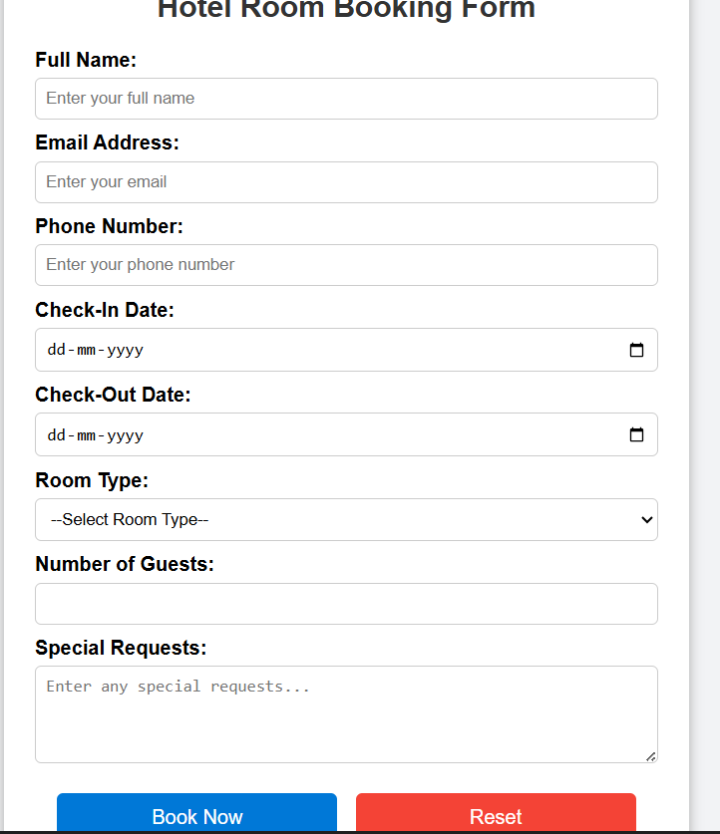

Outcome
- Successfully created a hotel room booking form webpage using HTML.
- Implemented input fields, labels, select, textarea, and buttons.
- Learned practical form design techniques for web applications.

